# Digital Image Processing

**Assignment 1**

| **Name** | **Reg. No** |
| --- | --- |
|  |  |
| Muhammad Suhaib | 378332 |
| Wahaj Ahmed Butt | 372890 |
| Abdullah Tahir | 385714 |

## Task 1:

Cropping an image to 256 by 256

Code:

import cv2 as cv

img = cv.imread("pics/pic1.jpg")

cv.imshow("Image", img)

resized_image = cv.resize(img, (256, 256))

cv.imshow("Image2", resized_image)

cv.waitKey(0)

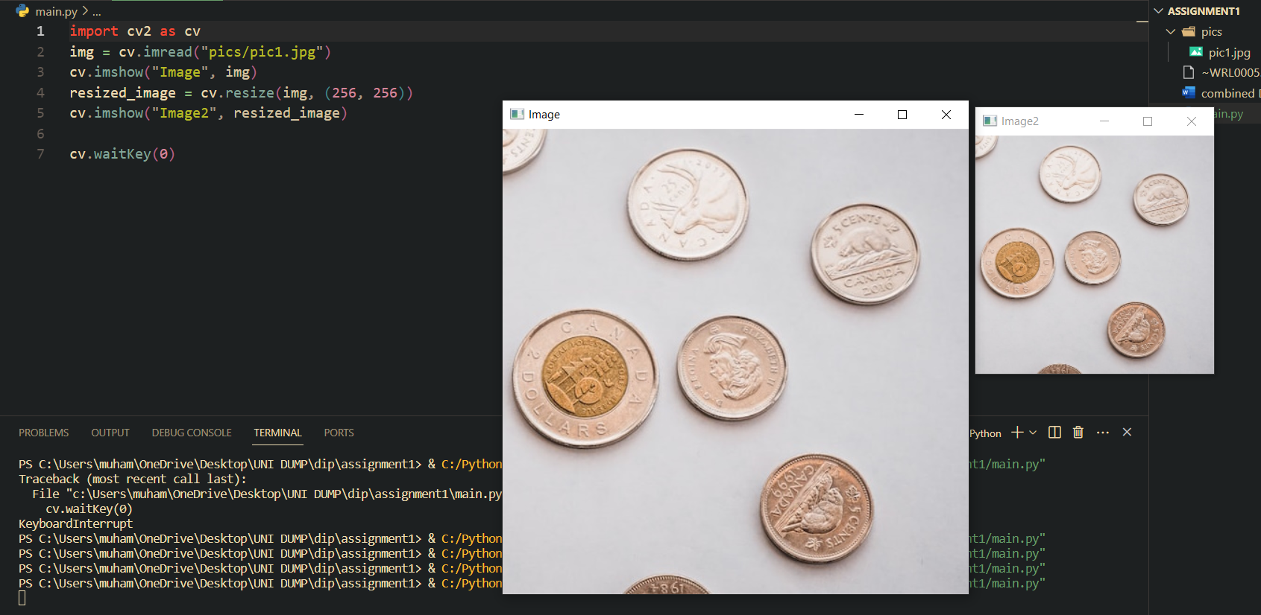

Task 2:

Code:

import cv2 as cv

img = cv.imread("pics/pic1.jpg")

cv.imshow("Image", img)

resized_image = cv.resize(img, (256, 256))

cv.imshow("Image2", resized_image)

gray_image = cv.cvtColor(resized_image, cv.**COLOR_BGR2GRAY**)

cv.imshow("Image3", gray_image)

cv.waitKey(0)

Output:

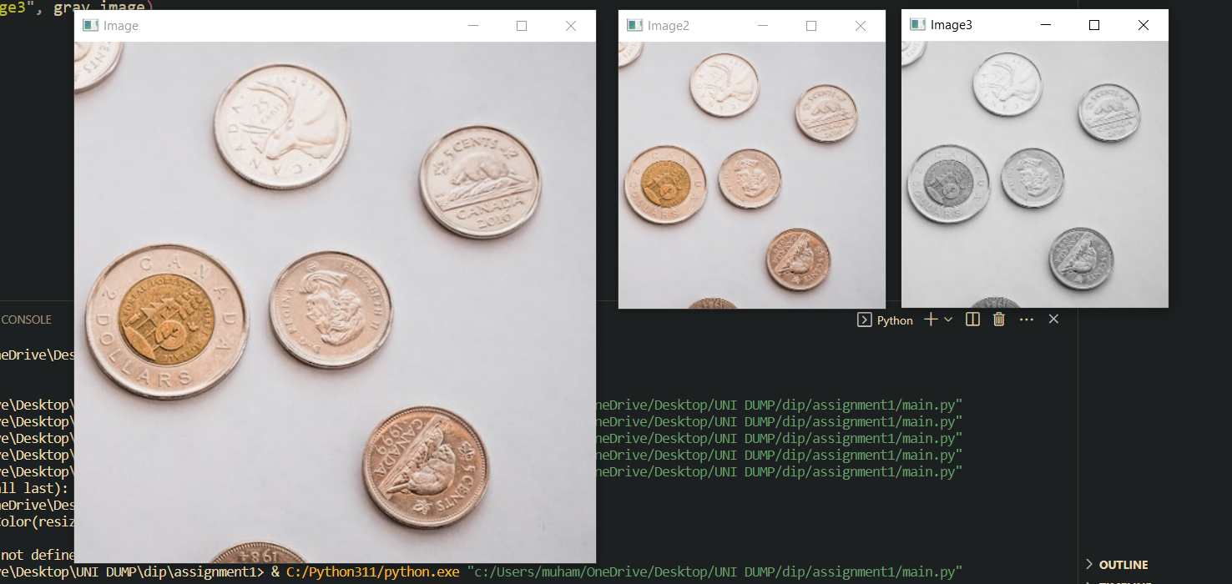

As can be see now the resize image is displayed in grey scale

Task 3:

Code:

import cv2 as cv

img = cv.imread("pics/pic1.jpg")

cv.imshow("Image", img)

resized_image = cv.resize(img, (256, 256))

cv.imshow("Image2", resized_image)

gray_image = cv.cvtColor(resized_image, cv.**COLOR_BGR2GRAY**)

cv.imshow("Image3", gray_image)

threshold_value = 170

_, binary_image = cv.threshold(gray_image, threshold_value, 255, cv.**THRESH_BINARY**)

cv.imshow("Image4", binary_image)

cv.waitKey(0)

Output:

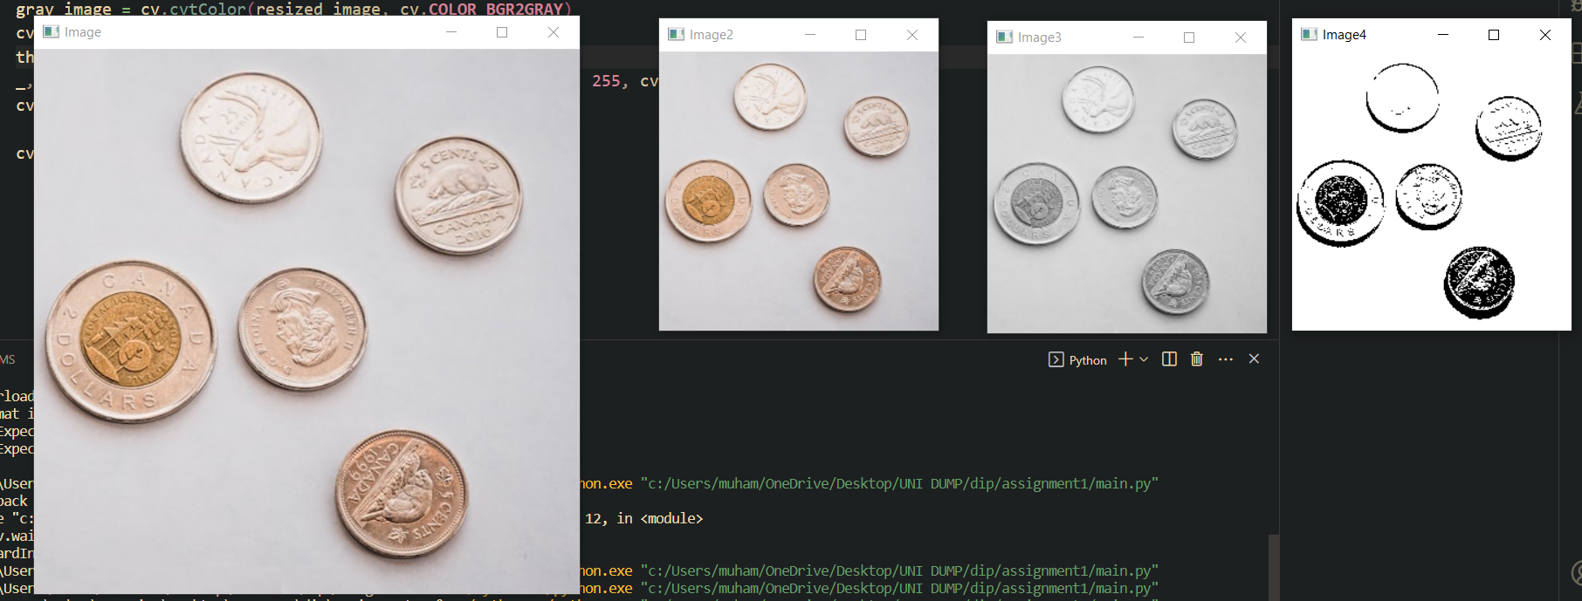

As can be seen now we are getting a binary image based on a specific threshold value which for this we have picked as 170.

Task 4:

Code:

blur_image = cv.GaussianBlur(gray_image, (5,5), 0)

canny_image = cv.Canny(blur_image, 30, 200, 3)

dilate_image = cv.dilate(canny_image, (5,5), *iterations*=5)

contours, _ = cv.findContours(dilate_image, cv.RETR_EXTERNAL, cv.CHAIN_APPROX_SIMPLE)

cv.drawContours(dilate_image, contours, -1, (0,0,255), 2)

print(f"Number of coins: {len(contours)}")

cv.imshow("Image 5",dilate_image)

Output:



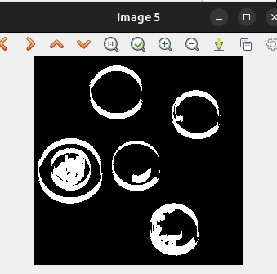

As we can see from the screenshot above, the contours around the image show us the number of coins in the photo.